TRIBHUVAN UNIVERSITY
Faculty of Humanities and Social Sciences
[College Name]

A PROJECT REPORT
Final Defense Report
Department of Computer Application
[College Name]

Submitted in partial fulfillment of the requirements for the Bachelor in Computer Application

NTB EVENT MANAGEMENT SYSTEM
A Smart Event Management Platform for Nepal Tourism Board

Submitted By:
Anjal Joshi
T.U. Registration Number: [T.U. Registration Number]
anjaljoshi6@gmail.com

Under the Supervision of
[Supervisor's Name]

August 2026

TRIBHUVAN UNIVERSITY
Faculty of Humanities and Social Sciences
[College Name]

SUPERVISOR'S RECOMMENDATION
I hereby recommend that this project report prepared under my supervision by Anjal Joshi (T.U. Registration Number: [T.U. Registration Number]) entitled “NTB Event Management System” in partial fulfillment of the requirements for the degree of Bachelor in Computer Application is recommended for the final evaluation.

……………………………………………

SIGNATURE
[Supervisor's Name]
SUPERVISOR
[College Name]

TRIBHUVAN UNIVERSITY
Faculty of Humanities and Social Sciences
[College Name]

LETTER OF APPROVAL
This is to certify that this project report prepared by Anjal Joshi (T.U. Registration Number: [T.U. Registration Number]) entitled “NTB Event Management System” in partial fulfillment of the requirements for the degree of Bachelor in Computer Application has been evaluated. In our opinion, it is satisfactory in the scope and quality of a project for the required degree.

……………………………………………
Project Supervisor

……………………………………………
Internal Examiner

……………………………………………
External Examiner

……………………………………………
Program Coordinator

Abstract
The NTB Event Management System is a complete, production-grade web platform built for the Nepal Tourism Board (NTB) to manage, publish, and promote events across Nepal. The system solves the lack of a centralized, intelligent platform where tourism-related festivals, meetings, holidays, and cultural events can be efficiently managed by administrators and discovered by the public. Beyond standard CRUD operations, the system incorporates four custom-built AI modules implemented natively in C#, without relying on any third-party AI service: a content-based recommendation engine (TF-IDF weighted vectors and Cosine Similarity), a smart search module (BM25 probabilistic ranking), an automated tag suggestion service (TF-IDF keyword extraction with Levenshtein fuzzy matching against existing tags), and a weighted popularity scoring model for event ranking. The backend is built using ASP.NET Core 8 following Clean Architecture principles with PostgreSQL as the database and a hybrid Entity Framework Core / Dapper data-access layer, while the frontend is built using SvelteKit and TypeScript acting as a backend-for-frontend. The platform also supports role-based access control (SuperAdmin, Admin, Client), JWT authentication with refresh-token rotation, a dual AD/BS calendar, and a full guest-invitation and QR-code check-in workflow. By the final defense, all four AI modules, the invitation/check-in feature, and a suite of 24 automated unit and system tests (xUnit + Moq) have been implemented, integrated end-to-end, and verified. All 24 tests pass, and the AI-powered search, recommendation, and tag-suggestion features have been confirmed against real seeded data.
Keywords: Event Management System, TF-IDF, Cosine Similarity, BM25, Content-Based Recommendation, Clean Architecture, ASP.NET Core, SvelteKit, PostgreSQL, JWT Authentication, QR Check-in.

Acknowledgement
I would like to express my sincere gratitude to my supervisor, [Supervisor's Name], for the continuous guidance, feedback, and support provided throughout the development of this project. Their direction was instrumental in shaping both the technical depth and the presentation of this work.
I would also like to thank the Department of Computer Application, [College Name], and all the faculty members who provided valuable feedback during the mid-term defense, which directly shaped the scope and quality of the AI modules and testing work completed for this final submission. Finally, I extend my thanks to my friends and family for their continuous encouragement throughout this project.

Anjal Joshi

Table of Contents
Right-click and select 'Update Field' to generate.

List of Figures
Right-click and select 'Update Field' to generate.

List of Tables
Right-click and select 'Update Field' to generate.

Abbreviations
Abbreviation | Full Form
AD | Anno Domini (English Calendar)
API | Application Programming Interface
BFF | Backend-for-Frontend
BM25 | Best Match 25 (probabilistic ranking function)
BS | Bikram Sambat (Nepali Calendar)
CRUD | Create, Read, Update, Delete
DTO | Data Transfer Object
EF Core | Entity Framework Core
EMS | Event Management System
ERD | Entity Relationship Diagram
HTTP | Hypertext Transfer Protocol
JWT | JSON Web Token
NTB | Nepal Tourism Board
ORM | Object-Relational Mapper
QR | Quick Response (code)
RBAC | Role-Based Access Control
REST | Representational State Transfer
SPA | Single Page Application
SQL | Structured Query Language
SSR | Server-Side Rendering
TF-IDF | Term Frequency-Inverse Document Frequency
UI/UX | User Interface / User Experience

Chapter 1: Introduction

1.1 Introduction
Nepal is a country of extraordinary cultural richness and natural diversity. Every year, hundreds of festivals, tourism events, national holidays, and community gatherings are organized across the country. The Nepal Tourism Board (NTB), as the official government body responsible for promoting Nepal as a tourism destination, plays a central role in organizing and publicizing these events to both domestic and international audiences.
However, managing and publishing this large volume of events through disconnected or manual processes creates significant operational inefficiencies. There is no unified, modern platform that brings event creation, publication, calendar management, and intelligent event discovery under one roof. The NTB Event Management System is built to solve exactly this problem.
This system is a full-stack web application where authorized administrators can create, update, and manage events of various types (festivals, meetings, holidays, and general events) and invite guests to them with QR-code based check-in. The public can browse, filter, and explore these events through an interactive calendar and listing interface. What sets this platform apart is the integration of self-built AI modules that enhance search quality, surface relevant events to users, and assist administrators with intelligent tag suggestions during event creation. By the final defense, every one of these modules has been implemented, integrated end-to-end, and covered by an automated test suite.

1.2 Problem Statement
Nepal's tourism event landscape suffers from fragmentation and lack of digital structure. The core problems that motivated this project are:
- No centralized digital platform exists for NTB to manage all event types from a single admin interface.
- The public has no reliable, filterable, and searchable directory of NTB-published events.
- Event discovery is passive, since users must scroll through lists with no intelligence behind what is surfaced.
- Manual content tagging is inconsistent, making category-based filtering less reliable.
- There is no way to track event popularity or surface trending or high-impact events automatically.
- Inviting and verifying guests at event venues is typically a manual, paper-based process prone to errors.
These gaps result in missed opportunities for tourism promotion, lower public awareness, and high administrative overhead. The NTB Event Management System directly addresses each of these problems through structured event management workflows, embedded AI-driven discovery features, and a digital guest invitation/check-in flow.

1.3 Objectives
The primary objectives of this project are as follows:
- To design and develop a complete, production-grade event management platform for the Nepal Tourism Board.
- To implement a role-based access control system that supports Super Admin, Admin, and Client roles with appropriate permissions.
- To build an interactive calendar interface that displays events in both month-view and list-view with dual-calendar support (AD and BS).
- To implement a custom-built Content-Based Recommendation Engine using TF-IDF and Cosine Similarity that suggests relevant events without relying on third-party AI APIs.
- To develop a smart search module powered by the BM25 ranking algorithm, replacing naive keyword matching with a probabilistic relevance model.
- To create an automated tag suggestion feature using keyword extraction so administrators receive intelligent recommendations while creating events.
- To implement a Weighted Popularity Scoring model that ranks events based on rating, attendance, recency, and featured status.
- To implement a guest invitation and QR-code based check-in system for event attendance verification.
- To ensure the platform follows Clean Architecture principles on the backend, ensuring maintainability and testability, and to validate correctness through automated unit and system testing.

1.4 Scope and Limitation
The scope of the NTB Event Management System covers the following areas:
- Full event lifecycle management: draft, publish, and archive.
- Multiple event types: Festival, Meeting, Holiday, and General Event.
- Image upload and media management for events.
- Category and tag management with support for many-to-many relationships.
- User management with role-based access: Super Admin, Admin, and Client.
- JWT-based authentication with refresh token rotation.
- Public-facing event discovery with calendar view, filtering, and smart search.
- AI-assisted content recommendation, search ranking, and tag suggestion.
- Support for both AD (English calendar) and BS (Bikram Sambat) date formats.
- Guest invitation via email with QR code generation, and door-side scan/verify check-in.
The current limitations of the system include:
- The recommendation engine is content-based; collaborative filtering (based on user behaviour history) is planned for future phases.
- The system does not currently support event ticketing or payment processing.
- Mobile native applications (iOS/Android) are outside the current scope; the platform is optimized as a responsive web application.
- The AI modules currently run at request time; background pre-computation and caching are planned as a future enhancement.

1.5 Development Methodology
This project follows an Agile-Incremental development methodology. Rather than planning and building everything at once, the system has been developed in iterative sprints, with each sprint delivering a working vertical slice of functionality that was reviewed and refined based on supervisor feedback before the next sprint began.
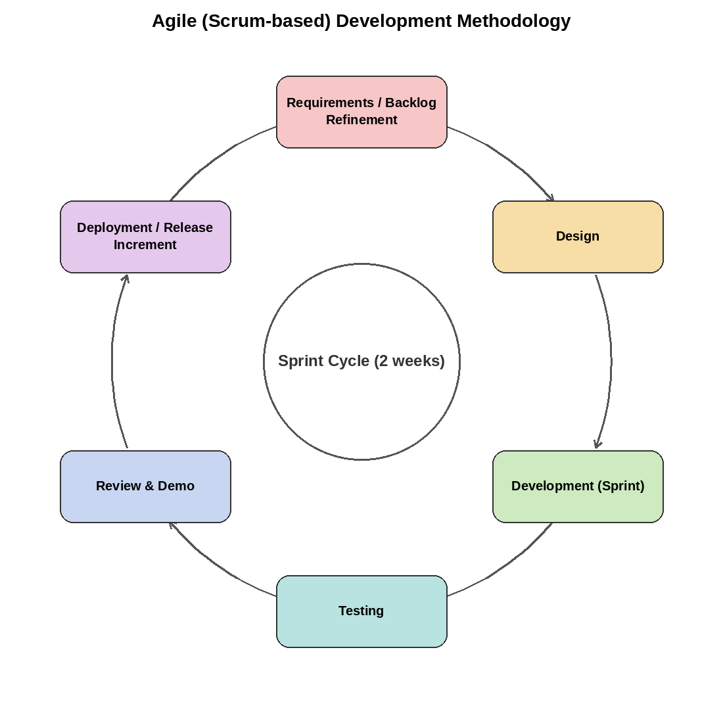
Figure 1: Agile (Scrum-based) Development Methodology
The development was divided into the following major increments:
- Increment 1 (Core Infrastructure): Database schema design, Clean Architecture project setup, JWT authentication, user roles, and basic event CRUD.
- Increment 2 (Frontend Foundation): SvelteKit project setup, admin panel layout, event creation/editing forms, and image upload.
- Increment 3 (Calendar and Public View): Interactive calendar with month/list toggle, public event discovery page, filtering, and category/region-based navigation.
- Increment 4 (AI Modules): TF-IDF and Cosine Similarity based recommendation engine, BM25 search ranking, keyword extraction with Levenshtein-based tag suggestion, and weighted popularity scoring, all implemented and integrated end-to-end.
- Increment 5 (Guest Invitations and QR Check-in): Invitation/guest data model, QR code generation, email delivery, and the admin door-side scan-and-verify flow.
- Increment 6 (Testing and Documentation): A 24-case automated test suite (xUnit + Moq) covering authentication, event CRUD, and all four AI modules, followed by result analysis and final report writing.
The project's schedule, spanning both the mid-term and final defense milestones, is summarized in the Gantt chart below.
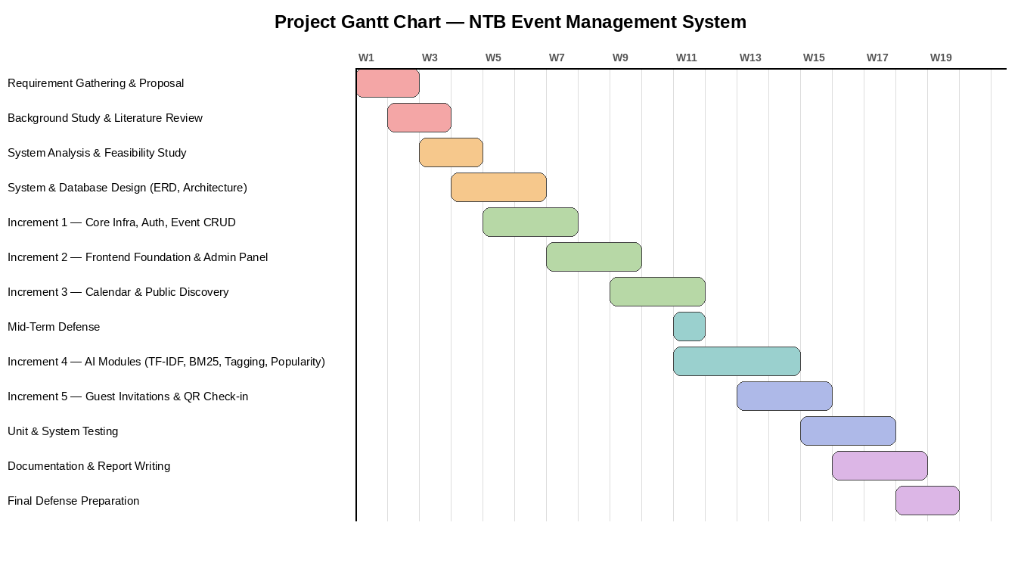
Figure 2: Project Gantt Chart
This incremental approach allowed continuous delivery of working functionality while enabling course corrections based on testing and supervisor feedback throughout the project lifecycle, most notably, the AI modules and the automated test suite, which were the primary gap closed between the mid-term and final defense.

1.6 Report Organization
This report is organized into five chapters:
- Chapter 1 (Introduction): Provides the background, problem statement, objectives, scope, and development methodology.
- Chapter 2 (Background Study and Literature Review): Covers the fundamental concepts and reviews similar systems and research work.
- Chapter 3 (System Analysis and Design): Presents the requirement analysis, feasibility study, system diagrams, interface design, and algorithm details.
- Chapter 4 (Implementation and Testing): Details the tools used, module implementations, test cases, and result analysis.
- Chapter 5 (Conclusion and Future Recommendations): Summarizes the completed work and outlines the future work planned.

Chapter 2: Background Study and Literature Review

2.1 Background Study
This chapter provides the theoretical foundation behind the key concepts used in the NTB Event Management System, with a particular focus on the AI and algorithmic components.

2.1.1 Event Management Systems
An Event Management System (EMS) is a software platform that facilitates the planning, organization, publication, and administration of events. Modern EMS platforms go beyond simple CRUD operations by integrating features such as calendar visualization, multi-role user access control, media management, and intelligent content discovery. In the context of a national tourism body like NTB, an EMS must be robust, scalable, and capable of serving both internal administrators and the general public simultaneously.

2.1.2 Content-Based Filtering and TF-IDF
Content-based filtering is a recommendation technique that suggests items similar to those a user has shown interest in, based on the properties of the items themselves rather than the behaviour of other users. In the context of event recommendation, if a user views a Dashain Festival event, the system should surface other festival events with similar topics, locations, or keywords.
Term Frequency-Inverse Document Frequency (TF-IDF) is a numerical statistic that reflects how important a word is to a document within a collection. The TF (Term Frequency) component measures how often a word appears in a document, while the IDF (Inverse Document Frequency) component reduces the weight of words that appear in many documents (common words) and increases the weight of rare, domain-specific words. Together, they produce a vector representation of a document that captures its meaningful content.

2.1.3 Cosine Similarity
Cosine Similarity is a metric used to measure the similarity between two vectors by computing the cosine of the angle between them in a multi-dimensional space. When two TF-IDF vectors are compared using cosine similarity, the result is a score between 0 and 1, where 1 means identical content and 0 means completely unrelated content. This is the mathematical core of the recommendation engine in this system.

2.1.4 BM25 – Probabilistic Information Retrieval
BM25 (Best Match 25), also known as Okapi BM25, is a ranking function used in information retrieval to rank documents based on their relevance to a given search query. Unlike a simple keyword match (ILIKE in SQL), BM25 accounts for the frequency of query terms in each document, the inverse document frequency of each term, and the document length, meaning longer documents are not unfairly rewarded for containing query terms more times. BM25 is the foundation of modern search engines like Elasticsearch and Lucene, and its implementation in this project provides significantly more relevant search results than plain pattern matching.

2.1.5 Weighted Scoring Models
A weighted scoring model is a simple but effective technique for ranking items based on multiple criteria simultaneously. Each criterion (e.g., rating, attendance, recency, featured status) is assigned a weight reflecting its relative importance. The final score is the weighted sum of all criteria. This technique is widely used in recommendation systems to surface popular or high-quality items without requiring complex machine learning infrastructure.

2.1.6 Keyword Extraction
Keyword extraction is the process of automatically identifying the most relevant and descriptive words or phrases from a piece of text. In this system, when an administrator is creating an event, the title and description are analysed to extract the top keywords using a TF-IDF-based approach against the existing event corpus. These keywords are then matched against the available tags in the system, using Levenshtein edit-distance for fuzzy matching, to produce intelligent tag suggestions.

2.2 Literature Review
Several existing event management and tourism platforms have been studied to understand the current state of the art and identify areas where the NTB system can provide better value.

2.2.1 Eventbrite
Eventbrite is one of the world's largest event management platforms. It supports event discovery, ticketing, and registration. Its recommendation system is primarily collaborative filtering-based, leveraging purchase history and user behaviour. While powerful, Eventbrite's approach requires large volumes of user behavioural data to function well, something that a new platform serving a national tourism body would not have at launch. The NTB system's content-based approach using TF-IDF and Cosine Similarity is more suitable for a cold-start scenario where user data is limited.

2.2.2 Nepal's Existing Tourism Information Portals
Nepal's existing government tourism portals (such as tourismdepartment.gov.np) primarily serve static informational content. They lack dynamic event management features, interactive calendars, admin workflows, or any form of intelligent event discovery. This confirms the gap that the NTB Event Management System is designed to fill.

2.2.3 Research on BM25 in Web Applications
Research by Robertson and Zaragoza (2009) established BM25 as a robust, parameter-tunable ranking algorithm for text retrieval. Subsequent work has shown that BM25 consistently outperforms simple TF-based models in precision and recall for domain-specific search tasks. Implementing BM25 natively within the application layer (rather than delegating to a full-text search engine) is a deliberate design choice in this project, demonstrating algorithm-level understanding rather than reliance on infrastructure abstractions.

2.2.4 TF-IDF in Recommendation Systems
Lops et al. (2011) provide a comprehensive survey of content-based filtering techniques and identify TF-IDF as a foundational and highly interpretable method for building item profiles in recommendation systems. The survey notes that TF-IDF based content-based filtering performs particularly well for text-rich domains, which aligns directly with the event management domain where events have rich titles, descriptions, categories, and tags.

Chapter 3: System Analysis and Design

3.1 System Analysis

3.1.1 Functional Requirements
The functional requirements of the NTB Event Management System are organized by user role:
Administrator Requirements:
- Admin can log in securely using email and password with JWT-based session management.
- Admin can create, edit, and delete events with full details including title, description, category, type, date (AD and BS), location, region, price, images, highlights, tags, and organizer information.
- Admin can change the lifecycle status of events: Draft, Published, or Archived.
- Admin can manage categories and tags, including creating and organizing tag-category associations, and can accept AI-suggested tags directly in the event form.
- Admin can manage system users and assign roles.
- Admin can view a calendar showing all events with color-coded type indicators.
- Admin can invite guests to an event by email, which generates and sends a QR code, and can scan/verify guest QR codes at check-in.
Public User Requirements:
- Public users can browse events on the homepage with featured event highlights, ranked by popularity score.
- Public users can filter events by type, category, region, and date range.
- Public users can use the smart search (BM25-ranked) to find events by title, location, or description.
- Public users can view events in both calendar and list view.
- Public users can view detailed event information including location, organizer, highlights, and images.
- Public users receive smart event recommendations (TF-IDF + Cosine Similarity) based on the event they are currently viewing.
- Invited guests can view their invitation landing page and present their QR code for check-in.

3.1.2 Non-Functional Requirements
- Performance: API response time should be under 200ms for standard queries; search and recommendation results should return within 500ms.
- Security: All admin endpoints are protected by JWT authentication. Passwords are hashed using BCrypt. Refresh token rotation prevents token replay attacks.
- Scalability: The Clean Architecture design ensures business logic is decoupled from infrastructure, enabling horizontal scaling when needed.
- Usability: The frontend must be responsive and work seamlessly on both desktop and mobile devices.
- Maintainability: Clean Architecture layers (Domain, Application, Infrastructure, API) ensure clear separation of concerns.
- Data Integrity: Dual-calendar date support (AD/BS) must be consistently maintained across all event records.
- Testability: All core services (auth, event CRUD, and the four AI modules) are covered by an automated unit/system test suite.

3.1.3 Use Case Diagram
The use case diagram below summarizes how the two main actor groups, public users/clients and administrators, interact with the system.
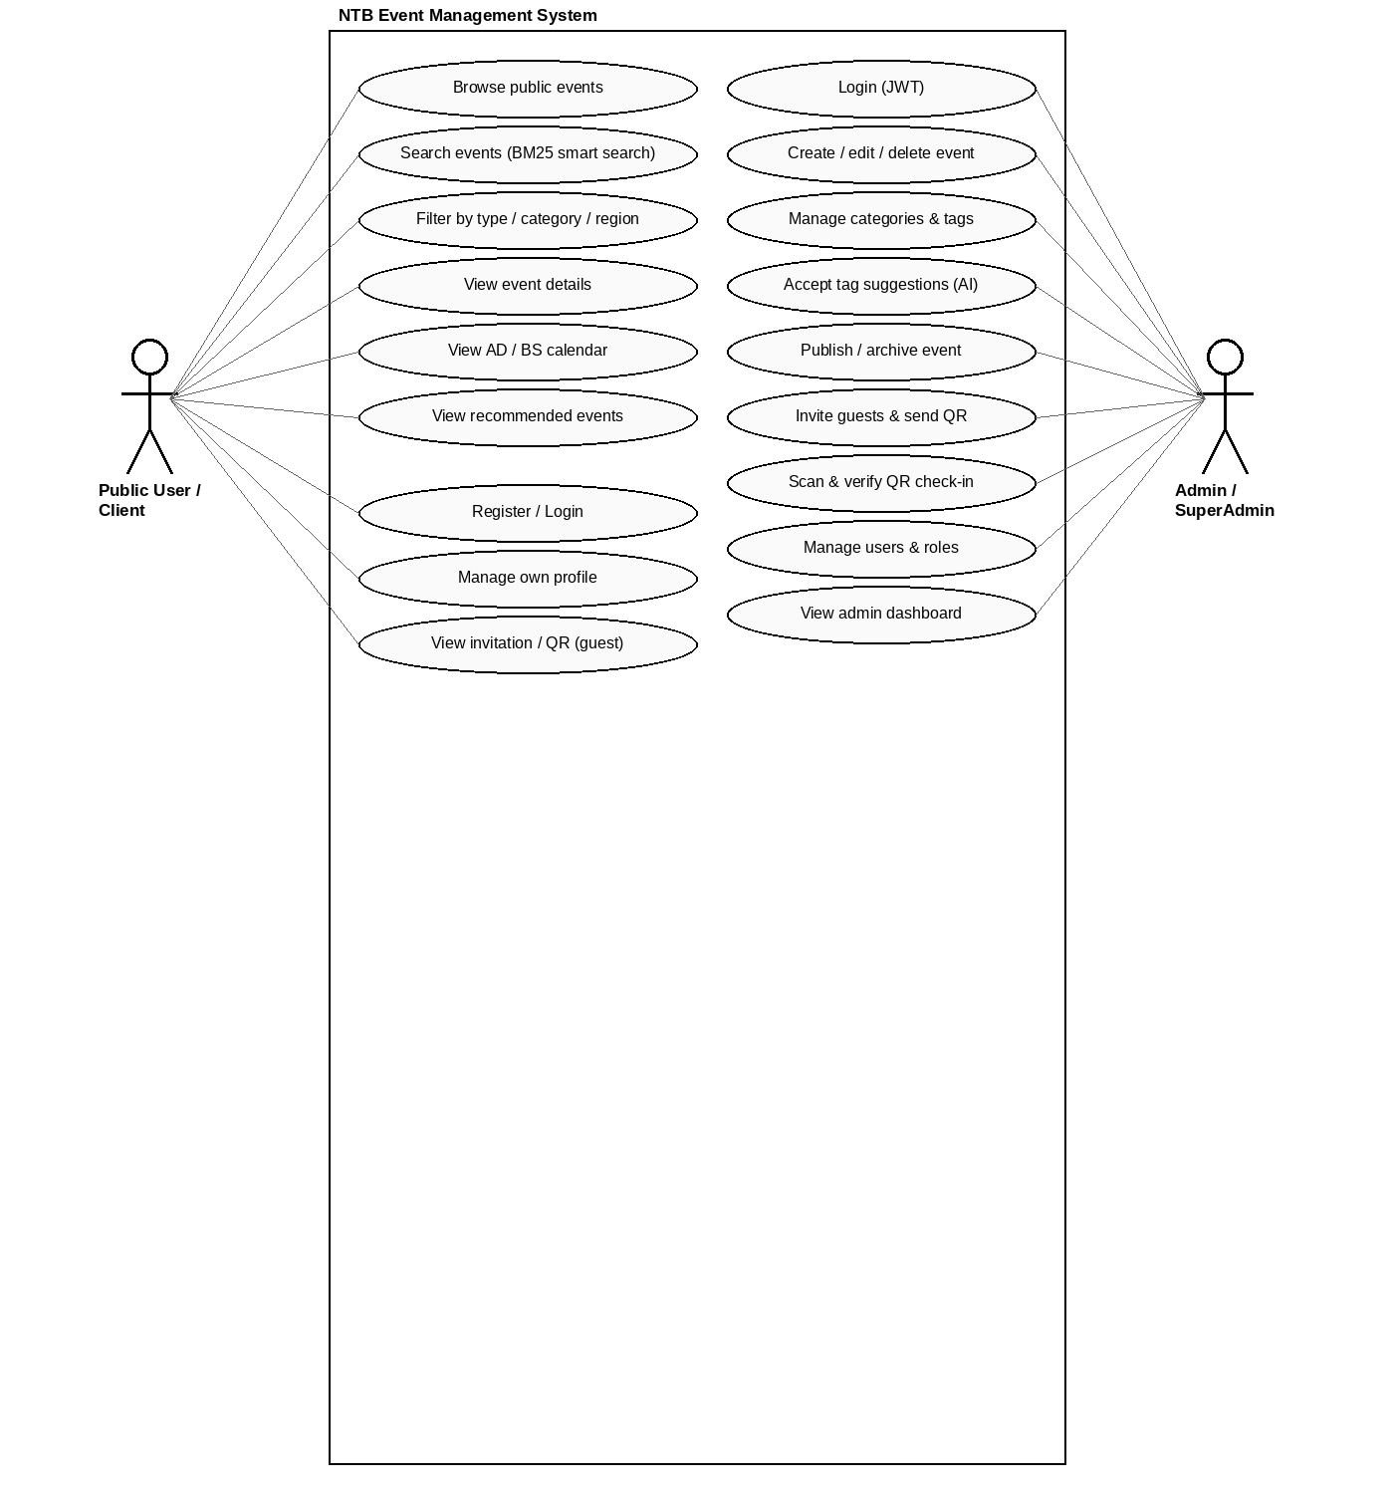
Figure 3: Use Case Diagram

3.2 Feasibility Analysis

3.2.1 Technical Feasibility
The system is built on mature, well-supported technologies. ASP.NET Core 8 is a production-grade web framework maintained by Microsoft. PostgreSQL is a battle-tested, open-source relational database. SvelteKit is a modern, performant web framework. The AI algorithms (TF-IDF, Cosine Similarity, BM25) are mathematically well-defined and have been implemented in pure C# without any external AI library dependencies, confirming technical feasibility in practice, not just in theory.

3.2.2 Operational Feasibility
NTB administrators are familiar with web-based administration tools. The system's admin interface is designed to be intuitive and requires minimal training. The public-facing interface is simple and discoverable. From an operational standpoint, the system reduces manual event publication effort and eliminates the need for external tools or third-party content management platforms.

3.2.3 Economic Feasibility
The entire technology stack is open-source with no licensing fees. The system can be hosted on cloud providers (such as AWS, Azure, or DigitalOcean) at a low monthly cost. Development effort is entirely student-driven. The long-term cost savings from eliminating manual event management workflows and reducing dependence on external platforms make the system economically viable for NTB.

3.3 System Design

3.3.1 System Architecture Overview
The NTB Event Management System follows Clean Architecture on the backend, organized into four distinct layers, with the SvelteKit frontend acting as a backend-for-frontend (BFF) that proxies requests to the API rather than exposing the access token to the browser directly.
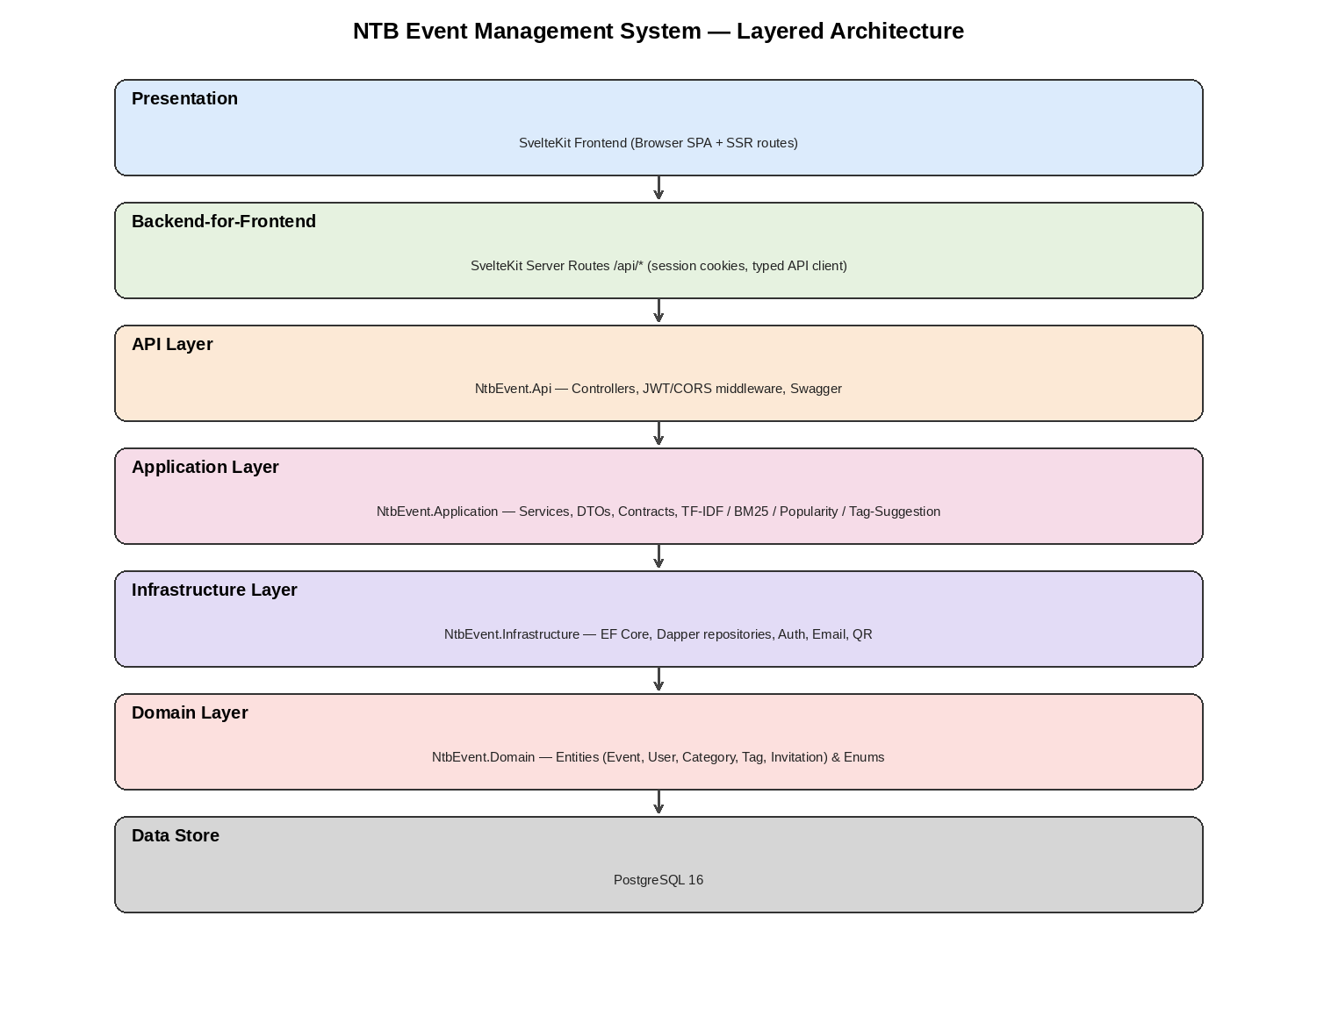
Figure 4: Layered System Architecture
- Domain Layer: Contains the core business entities (Event, User, Category, Tag, RefreshToken, EventHighlight, Guest, Invitation) and enumerations (EventType, EventLifecycleStatus, UserRole). This layer has no dependencies on any external framework.
- Application Layer: Contains service interfaces, repository contracts, DTOs, and business logic, including the TF-IDF vectorizer, BM25 ranker, popularity scorer, and tag suggestion service. It depends only on the Domain layer.
- Infrastructure Layer: Implements the repository contracts and services defined in the Application layer. It uses Entity Framework Core for CRUD operations, Dapper for performance-critical list queries, BCrypt for password hashing, QRCoder for QR generation, and SMTP for email delivery.
- API Layer: Hosts the ASP.NET Core controllers, handles HTTP request/response, JWT configuration, CORS, Swagger documentation, and dependency injection wiring.

3.3.2 Database Design
The primary entities and their relationships in the PostgreSQL database are shown below.
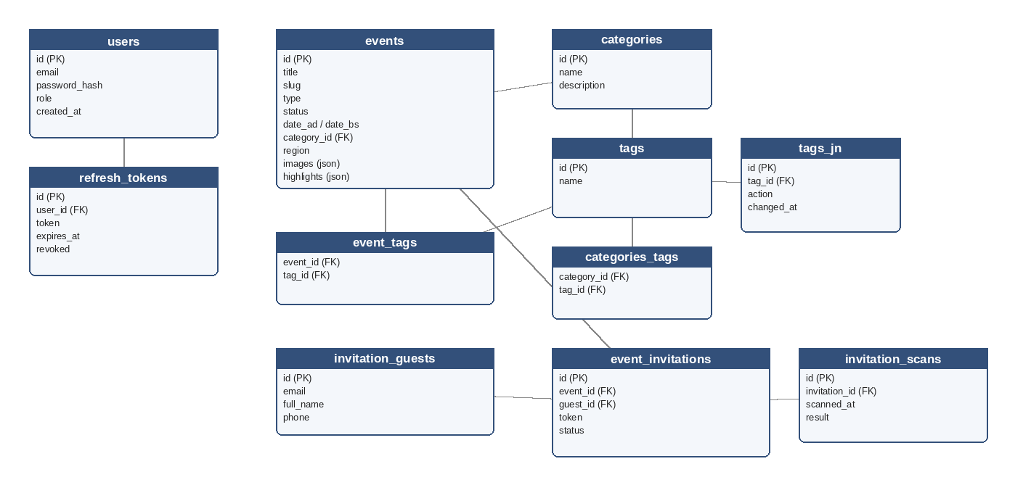
Figure 5: Database Schema Design (Entity Relationship Diagram)
- events: Stores all event data including title, description, dates (AD and BS), location, region, type, status, images, price, rating, organizer information, and highlighted features as a JSON column.
- users: Stores registered user accounts with hashed passwords and role assignments.
- refresh_tokens: Stores refresh tokens per user session for secure token rotation.
- categories: Stores event categories managed by administrators.
- tags: Stores descriptive tags that can be associated with events and categories.
- event_tags: Junction table linking events to tags (many-to-many).
- categories_tags: Junction table linking categories to their default tags.
- tags_jn (Audit): Tracks tag association changes for audit purposes.
- invitation_guests: One row per unique invited person (normalized by email), reused across events.
- event_invitations: Event–guest association holding the invite token, status (pending/sent/verified/expired/cancelled), expiry, and check-in audit fields.
- invitation_scans: One audit row per QR scan attempt at check-in.

3.3.3 API Design
The backend exposes the following RESTful API endpoints:
- POST /api/auth/login: Authenticate user and receive JWT + refresh token.
- POST /api/auth/refresh: Rotate refresh token and issue a new access token.
- POST /api/auth/logout: Invalidate the current refresh token.
- GET /api/events: Get paginated, filtered list of events (public).
- GET /api/events/{id}: Get a single event by ID.
- GET /api/events/{slug}: Get a single event by slug.
- POST /api/events: Create a new event (Admin).
- PUT /api/events/{id}: Update an event (Admin).
- DELETE /api/events/{id}: Delete an event (Admin).
- GET /api/events/{id}/recommendations: Get AI-powered recommendations for an event.
- GET /api/events/search?q={query}: Smart BM25-ranked search.
- POST /api/events/suggest-tags: Get AI-suggested tags for a title and description.
- GET /api/categories: List all categories.
- GET /api/tags: List all tags, optionally filtered by category.
- POST /api/events/{eventId}/invitations: Invite a guest (generates QR + emails them).
- GET /api/events/{eventId}/invitations: List an event's invitations.
- POST /api/invitations/scan: Look up an invitation by scanned token (no consume).
- POST /api/invitations/{id}/verify: Confirm check-in and expire the QR.
- GET /api/invitations/by-token/{token}: Public guest landing data.

3.3.4 Interface Design (UI/UX)
The following screenshots, captured from the running application, illustrate the primary public and administrative interfaces.
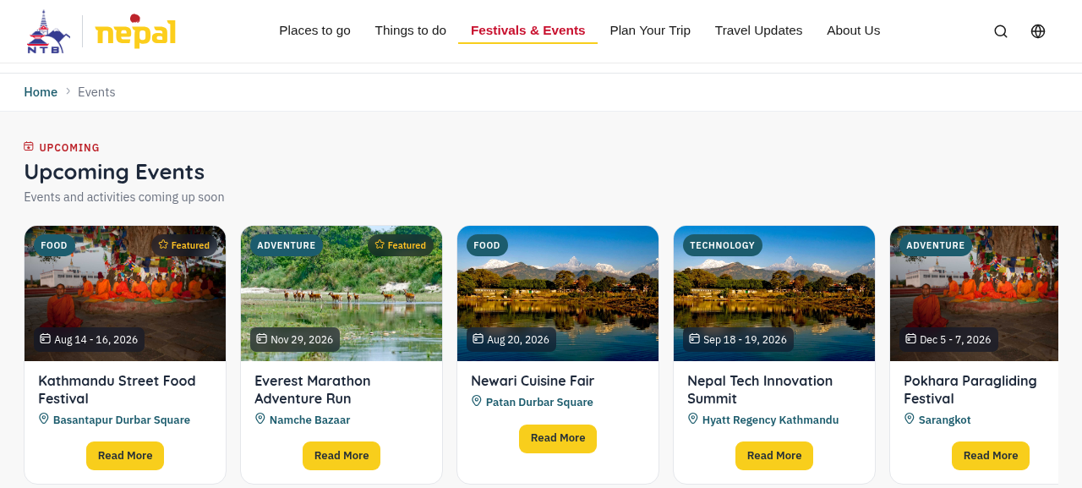
Figure 6: Public Homepage: Featured Events
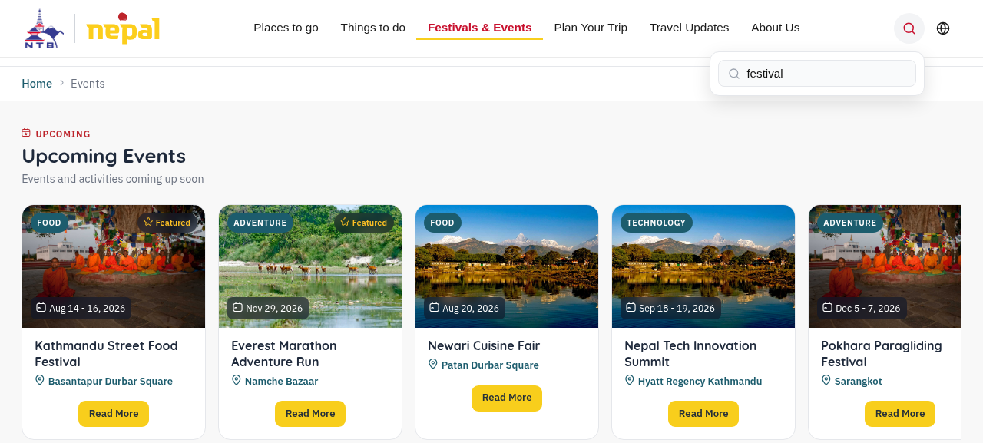
Figure 7: Smart Search Results (BM25-ranked)
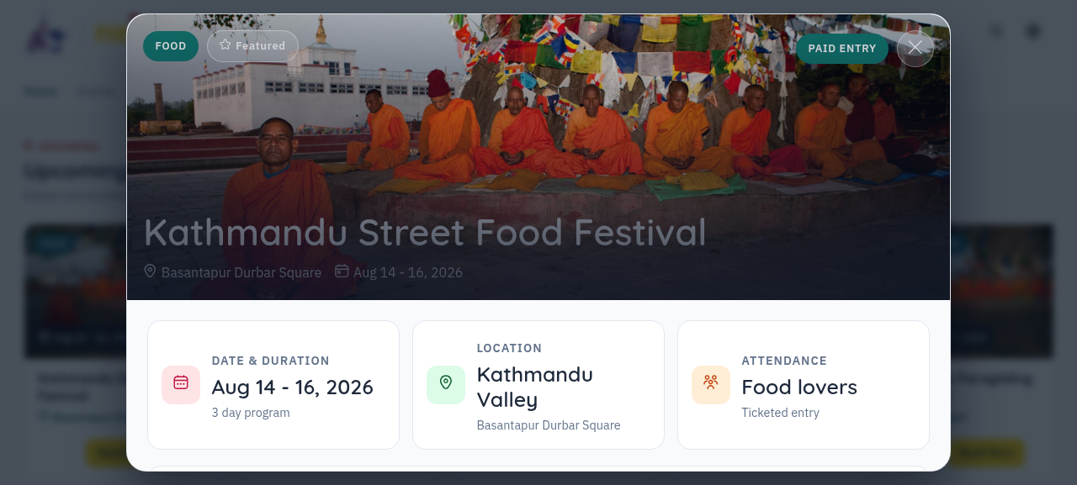
Figure 8: Event Details Modal
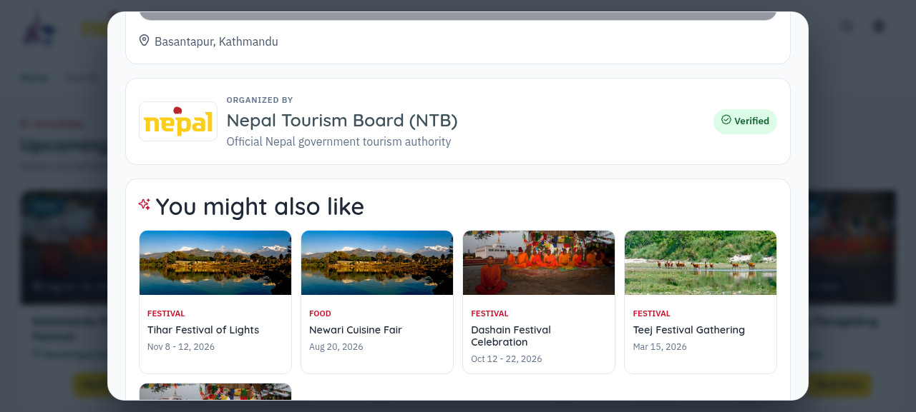
Figure 9: “You Might Also Like”: AI-Powered Recommendations
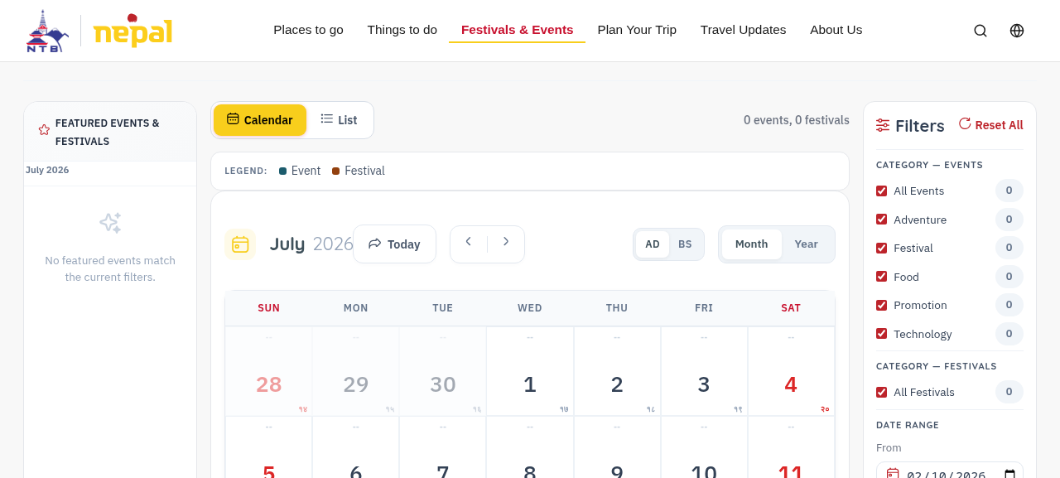
Figure 10: Public Interactive Calendar (AD/BS Toggle)
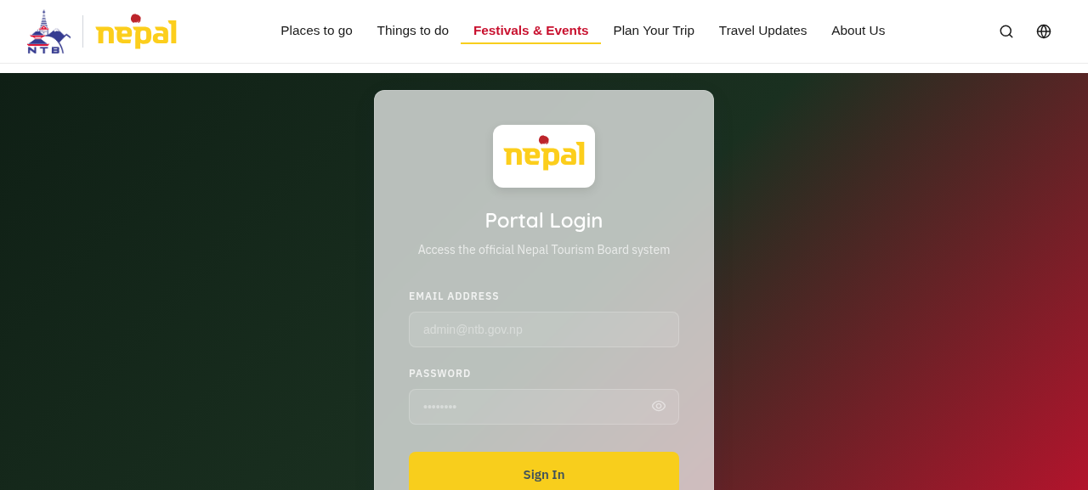
Figure 11: Admin Login Page
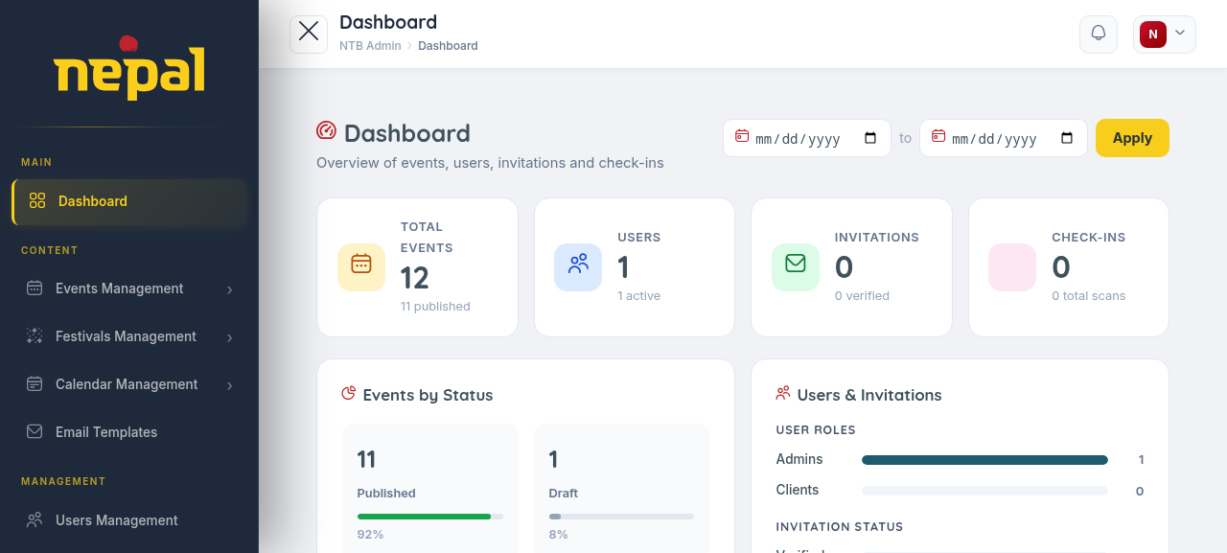
Figure 12: Admin Dashboard
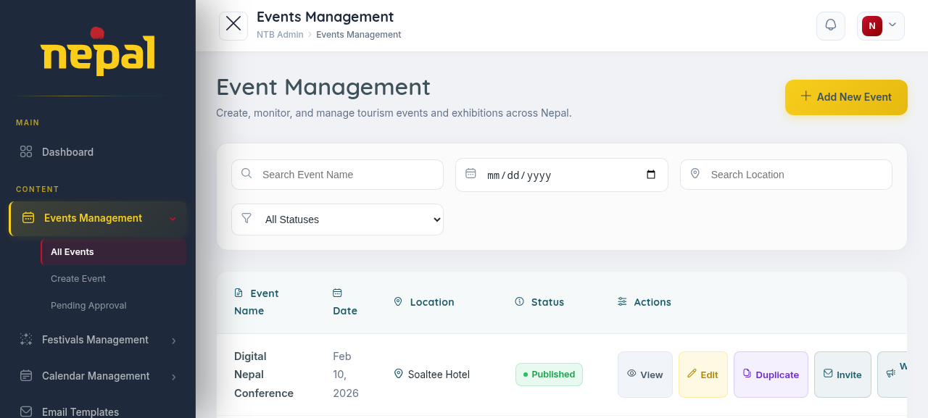
Figure 13: Admin Events Management List
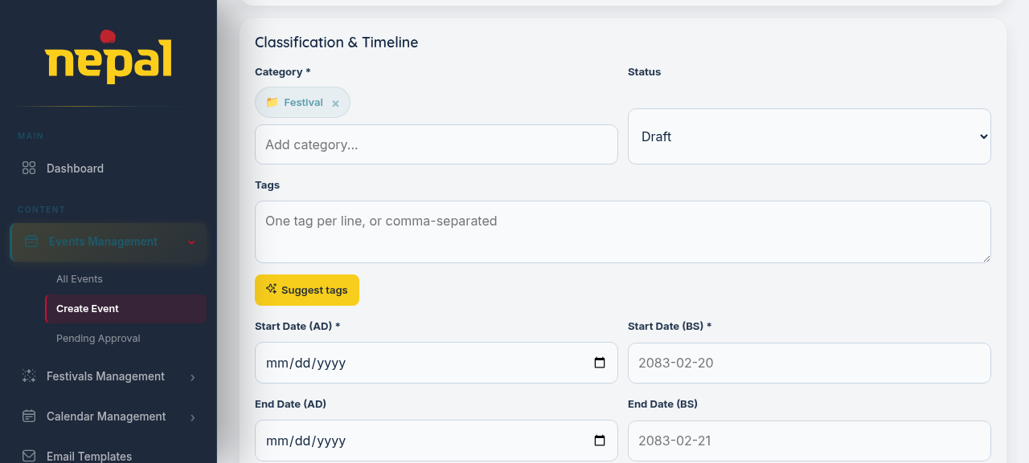
Figure 14: Admin: Create Event Form (Category, Status, Tags)
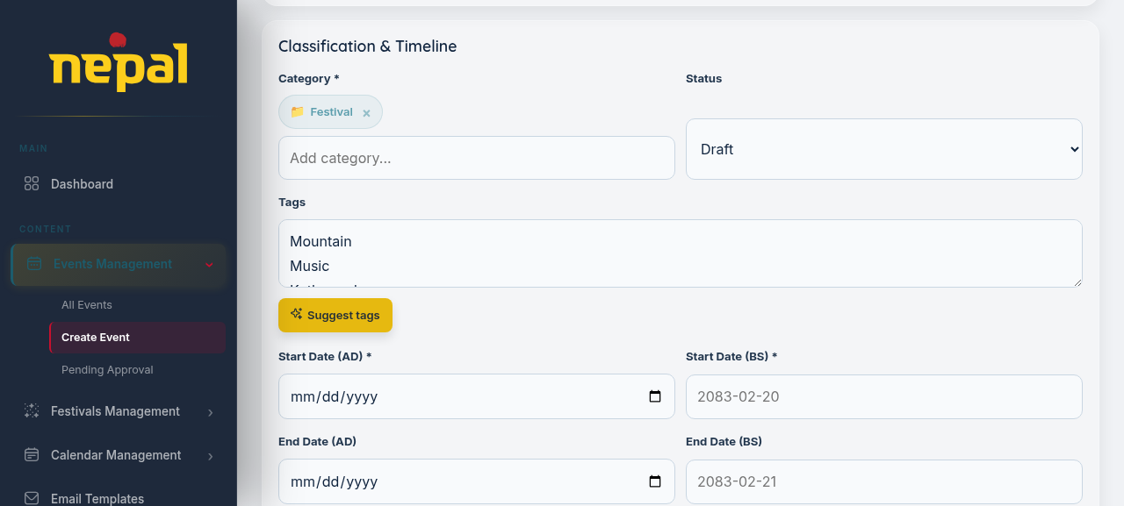
Figure 15: Admin Event Create: AI Tag Suggestion in Action
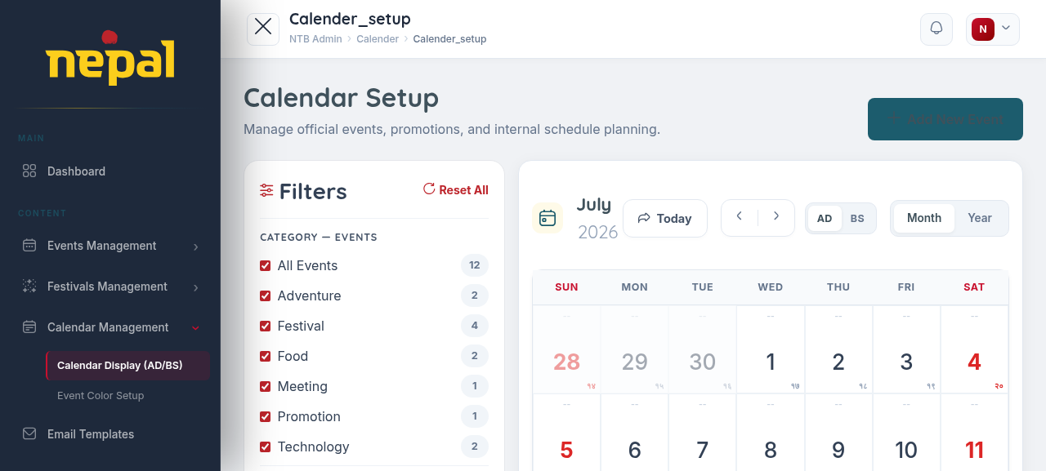
Figure 16: Admin Calendar Setup (AD/BS, category filters)

3.4 Algorithm Details
This section describes the four AI and algorithmic modules implemented natively within the NTB Event Management System. All algorithms are implemented in C# within the Application/Infrastructure layers and do not depend on any external AI API or service.

3.4.1 Content-Based Event Recommendation Engine (TF-IDF + Cosine Similarity)
The recommendation engine answers the question: given the event a user is currently viewing, which other events are most similar in content? This is a classic content-based filtering problem solved using TF-IDF vectorization and Cosine Similarity, implemented in RecommendationService using the shared TfIdfVectorizer utility.
Step 1: Build the Event Corpus
Each event in the database is represented as a text document by concatenating its most meaningful text fields: title (weighted 3×), summary (weighted 2×), long description, category name, region, and associated tags. Title repetition amplifies its influence on the final vector; this is a standard technique in content-based systems.
Step 2: Compute TF-IDF Vectors
For each event document, the system tokenizes the text (via TextTokenizer), removes stop words (common words such as 'the', 'is', 'in' which carry no meaning), and computes TF-IDF scores for each remaining token. The vocabulary is built from all events in the corpus.
The TF-IDF formula used is:
TF(t, d) = (count of term t in document d) / (total terms in document d)
IDF(t) = log( (1 + N) / (1 + df(t)) ) + 1
TF-IDF(t, d) = TF(t, d) × IDF(t)
Where N is the total number of event documents and df(t) is the number of documents that contain term t. The +1 smoothing in the IDF formula prevents zero values for terms that appear in every document.
Step 3: Compute Cosine Similarity
Given the TF-IDF vector of the target event (the one being viewed) and the TF-IDF vectors of all other events, cosine similarity is computed as:
similarity(A, B) = (A · B) / (||A|| × ||B||)
Where A · B is the dot product of the two vectors and ||A|| and ||B|| are their magnitudes. This gives a score between 0 and 1 for each pair. Events are then sorted by descending similarity score, and the top-N results (default: 5) are returned as recommendations, restricted to published events only.
Why This Is Not a SQL Query:
This algorithm operates entirely in the C# application layer. The database is used only to retrieve event data. The TF-IDF computation, vector construction, and similarity scoring are all done in memory using mathematical operations, not SQL filters or joins. This is verified end-to-end by the system test Recommendations_ForFestivalEvent_ReturnsSimilarCategoryEventsOnly.

3.4.2 Smart Search with BM25 Ranking
The smart search module (SearchRankingService) replaces the naive ILIKE pattern matching with a proper probabilistic ranking model called BM25 (Best Match 25), which is the same ranking function used by Elasticsearch, Solr, and many major search engines internally. The admin panel's existing ILIKE-based filter (BuildWhereClause) was intentionally left untouched; the BM25 search is a separate, additive public search path exposed at GET /api/events/search.
How BM25 Works:
Given a user's search query Q containing terms q1, q2, ..., qn, BM25 scores each event document D as follows:
Score(D, Q) = Σ IDF(qi) × [ f(qi, D) × (k1 + 1) ] / [ f(qi, D) + k1 × (1 - b + b × |D| / avgdl) ]
Where:
- f(qi, D) is the frequency of query term qi in document D.
- |D| is the length of document D in words.
- avgdl is the average document length across all events.
- k1 is a term saturation parameter (implemented value: 1.5) that controls how much repeated terms increase the score.
- b is a length normalization parameter (implemented value: 0.75) that controls how much document length affects scoring.
Each event's searchable text (title + summary + location + region) is tokenized and indexed into an in-memory inverted index built by Bm25Ranker. When a search query arrives, BM25 scores are computed in O(k) time where k is the number of matching terms.
Why BM25 Over ILIKE:
A plain ILIKE query in SQL returns all events that simply contain the search term, with no relevance ranking. BM25 assigns higher scores to events where the query terms appear frequently but the document is not artificially long, and where the query terms are rare across the corpus (more discriminative). This is verified by the system test SmartSearch_DashainFestivalQuery_RanksFestivalEventsHigher, confirming that festival events rank above unrelated events for a festival-specific query.

3.4.3 Automated Tag Suggestion via Keyword Extraction
When an administrator is in the process of creating or editing an event, TagSuggestionService automatically analyses the event's title and description to suggest relevant tags. This reduces manual tagging effort and improves consistency across the event catalog.
How It Works:
The keyword extraction module uses a corpus-aware TF-IDF scoring approach:
- The input text (title + description) is tokenized and stop words are removed.
- TF-IDF scores are computed for each token in the input text against the published-event corpus.
- The top-K tokens by TF-IDF score are selected as candidate keywords.
- Each candidate keyword is matched against the system's existing tag list using normalized string comparison and Levenshtein edit distance for fuzzy matching.
- Matched tags are returned in ranked order as suggestions to the administrator via the 'Suggest tags' button on the event form.
This process is entirely self-contained. It uses the event corpus already stored in the database and the tag dictionary maintained by administrators. No external NLP service or API is called. It has been verified end-to-end, including a fuzzy-match case where the typo “festivle” correctly resolved to the existing tag “Festival”.

3.4.4 Weighted Popularity Scoring for Event Ranking
To surface the most valuable events to users on the homepage and in category listings, PopularityScoreService computes a Popularity Score for each event using a multi-factor weighted formula. This is not a machine learning model; it is a transparent, tunable scoring function that administrators can understand and adjust.
Scoring Formula:
PopularityScore(e) = (W_r × NormalizedRating) + (W_a × NormalizedAttendance) + (W_f × FeaturedBoost) + (W_d × RecencyScore)
Where the weights are:
- W_r = 0.35: Rating weight (user ratings are the strongest signal of quality).
- W_a = 0.25: Attendance/engagement weight.
- W_f = 0.20: Featured boost (admin-marked events get a boost).
- W_d = 0.20: Recency score (more recent events rank higher to keep listings fresh).
NormalizedRating is computed as (event_rating / max_rating). Since the domain model does not carry a numeric attendance field (AttendanceLabel is free text), NormalizedAttendance uses ReviewsLabel as a practical proxy. RecencyScore uses an exponential decay function: RecencyScore = e^(−λ × days_since_event_start), where λ = 0.01 ensures that events decay gradually over ~100 days. This formula is computed entirely in C# without any database aggregation query. EventDto.PopularityScore is populated on every event read, and the public homepage's featured events section (EventsLandingSection.svelte) sorts by this score descending.
Why This Matters:
Without this scoring model, events would simply be sorted by creation date or start date. The weighted model ensures that high-rated, well-attended, recently-starting festivals appear prominently, which is exactly what NTB wants: showcasing Nepal's most impactful tourism events to visitors.

Chapter 4: Implementation and Testing

4.1 Implementation

4.1.1 Tools and Technologies Used
Table 1: Tools and Technologies Used
Component | Technology | Purpose
Backend Framework | ASP.NET Core 8 | REST API, routing, middleware
Architecture Pattern | Clean Architecture | Separation of concerns, testability
Primary ORM | Entity Framework Core 8 | CRUD operations, migrations
Query Micro-ORM | Dapper | Performance-optimised list queries
Database | PostgreSQL 16 | Relational data storage
Authentication | JWT + Refresh Tokens | Stateless, secure session management
Password Hashing | BCrypt.Net | Secure credential storage
QR Code Generation | QRCoder | Guest invitation QR codes
Email Delivery | SMTP (Mailcow-compatible) | Invitation emails, dev-mode logging fallback
Frontend Framework | SvelteKit + TypeScript | Reactive, performant UI
Styling | CSS Variables + Tailwind | Responsive design system
API Documentation | Swagger / OpenAPI | Interactive API explorer
AI Algorithms | Custom C# Modules | TF-IDF, BM25, Cosine Similarity, Popularity Scoring, Levenshtein
Testing | xUnit + Moq | Unit and system test automation
Version Control | Git / GitHub | Source code management

4.1.2 Module Implementation Details
Authentication Module:
The authentication module implements JWT access tokens with a short expiry (15 minutes) and long-lived refresh tokens stored in the database. On each successful refresh, the old token is invalidated and a new one is issued (token rotation). This prevents refresh token reuse attacks. The User entity carries a UserRole enum (SuperAdmin, Admin, Client) that is embedded in the JWT claims, enabling role-based route protection across all admin endpoints.
Event Management Module:
Events are created and managed through the EventsController, which delegates to the IEventService in the Application layer. The EventRepository uses Entity Framework Core for CRUD operations and Dapper for the paginated list query. The list query uses a dynamic WHERE clause builder (BuildWhereClause) that constructs parameterized SQL based on the active filters, preventing SQL injection while maintaining query flexibility. Events support dual dates (DateAd/DateBs), multiple images stored as a JSON array, and structured highlights stored as a JSON column.
Calendar Module:
The frontend calendar is built as a custom SvelteKit component with no external calendar library dependency. It supports month-view and list-view toggles. Events are color-coded by type (Festival, Meeting, Holiday, Event). The calendar supports both AD and BS date display through a toggle mechanism, with the real AD↔BS conversion logic implemented in the frontend's dateUtils.ts.
Tag and Category Module:
Categories and tags have a many-to-many relationship through the CategoriesTags junction. Events also relate to tags through the EventTags junction. An audit table (TagsJn) tracks changes to tag associations over time. The tag suggestion AI module (described in Chapter 3) operates on top of this data structure, and its 'Suggest tags' button was added to the admin event create/edit form together with a visible Tags field.
Guest Invitation & QR Check-in Module:
This module spans all layers: the Guest, Invitation, and InvitationScan entities (Domain), InvitationService and its contracts (Application), GuestRepository, InvitationRepository, QrCodeService, and SmtpEmailService (Infrastructure), and InvitationsController (API). The flow is: an admin invites a guest → the guest receives an email with a link and QR code → the guest presents the QR at the venue → an admin scans it for a preview → the admin confirms verification, which consumes/expires the QR so it cannot be reused. Invitation status follows the lifecycle pending → sent → verified, with expired and cancelled as terminal states.
AI Modules: Implemented and Integrated
The four AI modules described in Section 3.4 have been fully implemented as services within the Application and Infrastructure layers and are wired into the API and the frontend:
- RecommendationService (IRecommendationService): TF-IDF vectorization and Cosine Similarity, exposed via GET /api/events/{id}/recommendations and surfaced as the “You might also like” section in EventDetailsModal.svelte.
- SearchRankingService (ISearchRankingService): BM25 inverted index and scoring, exposed via GET /api/events/search, driven by the search box in PublicNav.svelte.
- TagSuggestionService (ITagSuggestionService): TF-IDF keyword extraction with Levenshtein-based fuzzy tag matching, exposed via POST /api/events/suggest-tags and the admin event form's “Suggest tags” button.
- PopularityScoreService (IPopularityScoreService): Weighted scoring formula with exponential recency decay; EventDto.PopularityScore powers the homepage's featured-events ordering.
The shared numerical building blocks (TfIdfVectorizer, Bm25Ranker, TextTokenizer, and LevenshteinDistance) live in NtbEvent.Application/Common and are reused across all four services, avoiding duplicated tokenization or scoring logic.

4.2 Testing
An automated test project (NtbEvent.Tests, xUnit + Moq) was added covering both unit-level and system-level (cross-service) behaviour. System tests are wired against in-memory fakes of the repository interfaces rather than a live PostgreSQL host, which keeps the suite fast and deterministic while still exercising real service composition (EventService + RecommendationService + SearchRankingService + TagSuggestionService working together).

4.2.1 Unit Test Cases
Table 2: Unit Test Cases
Test Case ID | Module | Test | Result
UT-01 | Authentication | LoginAsync_ValidCredentials_ReturnsAccessAndRefreshTokens | Pass
UT-02 | Authentication | LoginAsync_InvalidPassword_ThrowsUnauthorized | Pass
UT-03 | Authentication | RefreshAsync_ExpiredToken_ThrowsUnauthorizedAndIssuesNoNewToken | Pass
UT-04 | Event CRUD | CreateEventAsync_AllFields_PersistsWithAutoGeneratedSlug | Pass
UT-05 | Event CRUD | UpdateEventAsync_StatusChangedToPublished_PersistsUpdatedStatus | Pass
UT-06 | Event CRUD | DeleteEventAsync_ExistingId_RemovesEvent | Pass
UT-07 | AI – TF-IDF | ComputeTfIdf_SingleDocument_TermsWeightedByFrequency | Pass
UT-08 | AI – Cosine Similarity | CosineSimilarity_IdenticalDocuments_ReturnsOne | Pass
UT-09 | AI – Cosine Similarity | CosineSimilarity_CompletelyDifferentDocuments_ReturnsNearZero | Pass
UT-10 | AI – BM25 | Rank_QueryTermInOneDocumentOnly_RanksThatDocumentFirst | Pass
UT-11 | AI – BM25 | Rank_NoMatchingTerms_ReturnsEmpty | Pass
UT-12 | AI – Tag Suggestion | SuggestTagsAsync_TitleWithFestivalKeyword_ReturnsRelevantExistingTag | Pass
UT-13 | AI – Tag Suggestion | SuggestTagsAsync_BlankTitleAndDescription_ReturnsEmpty | Pass
UT-14 | AI – Popularity Score | ScoreAll_HighRatingAndFeatured_ScoresHigherThanNonFeatured | Pass
UT-15 | AI – Popularity Score | RankByPopularity_ReturnsDescendingOrder | Pass
UT-16 | AI – Popularity Score | ScoreAll_EmptyList_DoesNotThrow | Pass

4.2.2 System Test Cases
Table 3: System Test Cases
Test Case ID | Scenario | Result
ST-01 | Admin creates event, publishes it, and public user views it on homepage | Pass
ST-02 | Public user searches “Dashain festival” using smart search | Pass
ST-03 | Public user views a festival event and requests recommendations | Pass
ST-04 | Admin creates a new event; system suggests tags from title/description | Pass
ST-05 | Public user filters events by region | Pass
ST-06 | Unauthenticated request to an admin-only endpoint is rejected (not anonymous) | Pass
ST-07 | Event created without an explicit BS date still stores a distinct BS date | Pass
ST-08 | Admin archives an event; it no longer appears in the public listing | Pass

Running dotnet test NtbEvent.Tests/NtbEvent.Tests.csproj executes all 16 unit tests and 8 system tests: Passed! – Failed: 0, Passed: 24, Skipped: 0, Total: 24 (completed in under one second).

4.3 Result Analysis
By the final defense, the following components have been implemented, integrated, and verified:
- Full backend infrastructure: Clean Architecture project structure, PostgreSQL schema with all EF Core migrations, EF Core + Dapper hybrid data access.
- User authentication: JWT login, refresh token rotation, role-based access control (SuperAdmin, Admin, Client).
- Complete Event CRUD: Create, read, update, delete with dual-date support, image upload, tags, highlights, and lifecycle status management.
- Category and tag management with many-to-many associations and audit tracking.
- Admin dashboard with event listing, pagination, status management, and category setup.
- Public homepage with featured events (sorted by popularity score), stats display, hero section, and navigation.
- Interactive calendar with month/list toggle, event color coding, day event panel, and BS/AD date toggle.
- Event filtering by type, category, region, and date range.
- Guest invitation and QR-code check-in: invite → email + QR → guest presents QR → admin scans → verifies → QR is consumed.
- All four AI modules (TF-IDF/Cosine Similarity recommendations, BM25 smart search, tag suggestion, and popularity scoring) are fully implemented, wired to the frontend, and verified against the live database (12 seeded events across 6 categories and 22 tags, spanning Kathmandu, Pokhara, and Solukhumbu).
- A 24-case automated test suite (xUnit + Moq) covering authentication, event CRUD, and all four AI modules; all 24 tests pass.
Manual verification against the seeded dataset additionally confirmed that the fuzzy tag matcher correctly resolves the typo “festivle” to the existing “Festival” tag, that BM25 search and TF-IDF recommendations return sensible, relevant results, and that the popularity-sorted featured events section renders correctly on the public homepage. The system is functionally complete relative to the objectives defined in Chapter 1.

Chapter 5: Conclusion and Future Recommendations

5.1 Conclusion
The NTB Event Management System represents a significant step forward in how Nepal's tourism events are managed, published, and discovered. This final phase has delivered a fully functional event management platform, covering the complete lifecycle from event creation by administrators to public discovery by users, plus a digital guest invitation and QR check-in workflow.
The project goes beyond a standard CRUD application by fully implementing and integrating four distinct AI modules: a content-based recommendation engine using TF-IDF and Cosine Similarity, a smart search module using the BM25 ranking algorithm, an automated tag suggestion system using keyword extraction with Levenshtein fuzzy matching, and a weighted popularity scoring model for intelligent event surfacing. All four are built natively in C# without delegating intelligence to third-party AI APIs. This demonstrates genuine algorithmic implementation rather than API integration, and the modules are backed by a 24-case automated test suite that passes in full.
The Clean Architecture backend ensures the codebase is maintainable and testable, the dual-calendar support (AD and BS) reflects the real-world requirement of serving a Nepali government context, and the guest invitation/QR check-in feature extends the platform beyond the scope originally defined at the mid-term. The system is feature-complete and deployment-ready.

5.2 Future Recommendations
The following enhancements are recommended for future iterations of the platform:
- Collaborative Filtering: Extend the recommendation engine with a collaborative filtering component that incorporates user behaviour data (view history, bookmarks) once the platform has accumulated sufficient user interaction data.
- Caching Layer: Implement an in-memory cache (using IMemoryCache in ASP.NET Core) for pre-computed TF-IDF vectors and BM25 indices to further improve response times for AI-powered endpoints as the event catalog grows.
- Event Ticketing: Add registration and ticketing capabilities, allowing users to register for paid events directly through the platform.
- Mobile-Responsive Native App: Build a companion mobile application using a cross-platform framework, reusing the existing API layer.
- Analytics Dashboard: Provide NTB administrators with insights into event views, search queries, popular categories, and regional engagement.
- Automated Notifications: Extend the existing invitation email system with subscription-based notifications when new events matching a user's interests are published.
- Event Review System: Allow authenticated users to leave ratings and reviews for events they have attended, enriching the data that powers the popularity scoring model beyond its current proxy signals.

References
[1] S. E. Robertson and H. Zaragoza, "The Probabilistic Relevance Framework: BM25 and Beyond," Foundations and Trends in Information Retrieval, vol. 3, no. 4, pp. 333–389, 2009.
[2] P. Lops, M. de Gemmis, and G. Semeraro, "Content-based Recommender Systems: State of the Art and Trends," in Recommender Systems Handbook, F. Ricci et al., Eds., Springer, 2011, pp. 73–105.
[3] G. Salton and C. Buckley, "Term-weighting approaches in automatic text retrieval," Information Processing and Management, vol. 24, no. 5, pp. 513–523, 1988.
[4] Microsoft, "ASP.NET Core documentation," Microsoft Docs, 2024. [Online]. Available: https://learn.microsoft.com/aspnet/core
[5] PostgreSQL Global Development Group, "PostgreSQL 16 Documentation," 2024. [Online]. Available: https://www.postgresql.org/docs/16/
[6] SvelteKit Contributors, "SvelteKit Documentation," 2024. [Online]. Available: https://kit.svelte.dev/docs
[7] R. Baeza-Yates and B. Ribeiro-Neto, Modern Information Retrieval: The Concepts and Technology behind Search, 2nd ed. ACM Press, 2011.
[8] C. D. Manning, P. Raghavan, and H. Schütze, Introduction to Information Retrieval. Cambridge University Press, 2008.
[9] V. I. Levenshtein, "Binary codes capable of correcting deletions, insertions, and reversals," Soviet Physics Doklady, vol. 10, no. 8, pp. 707–710, 1966.
[10] xUnit.net Contributors, "xUnit.net Documentation," 2024. [Online]. Available: https://xunit.net/

Appendices
Additional screenshots supporting the interface design discussed in Chapter 3 are provided below.
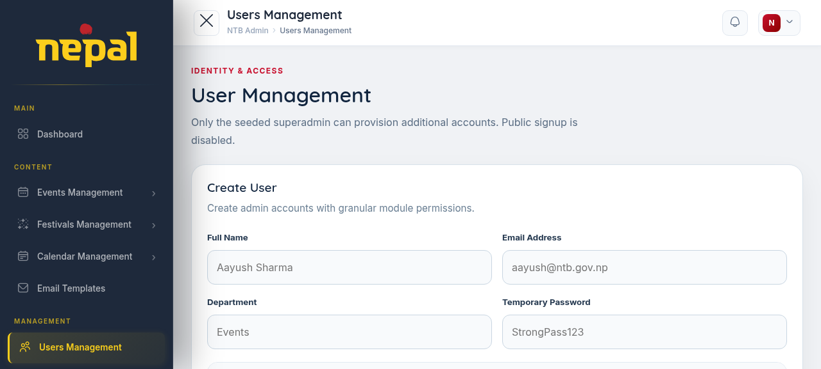
Figure 17: Admin: Create User with Module-Level Permissions
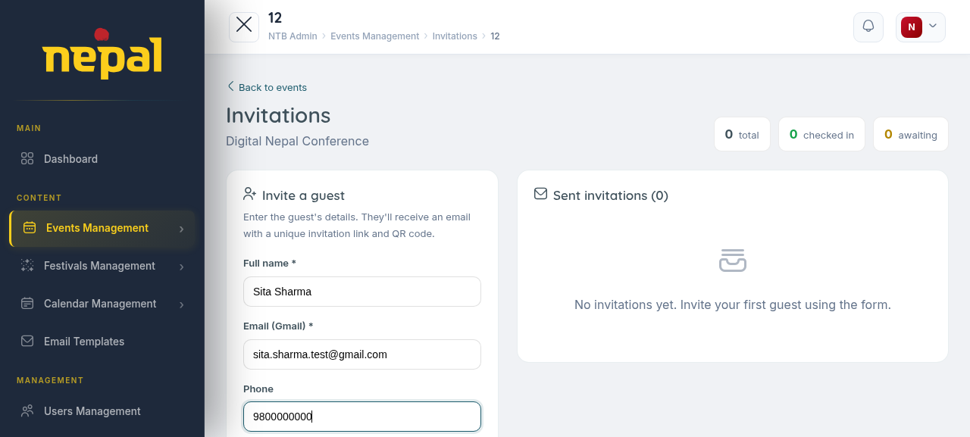
Figure 18: Admin: Guest Invitation Form (Event Check-in Stats)
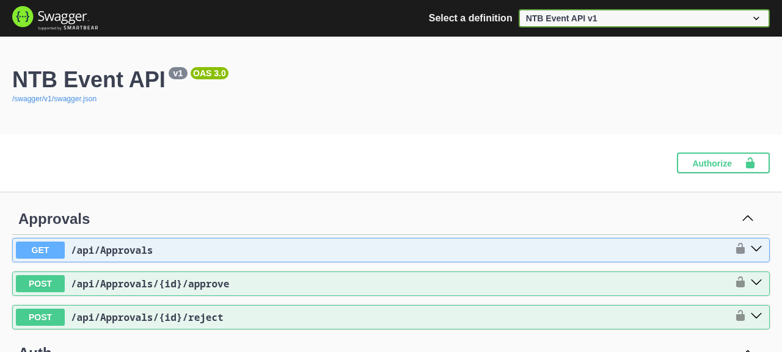
Figure 19: Swagger API Documentation

